Take up the Tchin-tchin Challenge in my camp with your campers from July 5th to 9th, 2021!
Dear camp counsellor,

Our camp is taking part in the Tchin-tchin Challenge in my camp which aims to encourage campers to drink water to promote their health and safety.
From July 5th to 9th, 2021, you are invited to take up the Tchin-tchin Challenge in my camp, by encouraging your campers to have a water bottle and to take a toast break in the morning and afternoon and to make a special place for water during meals.
During these three daily breaks, campers will drink water together in a fun atmosphere and raise their water bottles for a toast (Tchin-tchin!). As a role model, we encourage you to keep your own bottle next to you all week, to drink water regularly, and to join the campers in the toast during the breaks and at lunch. Although water is the preferred lunchtime beverage, campers can drink other beverages if they are packed in their lunches. However, the toast should only be done with water.
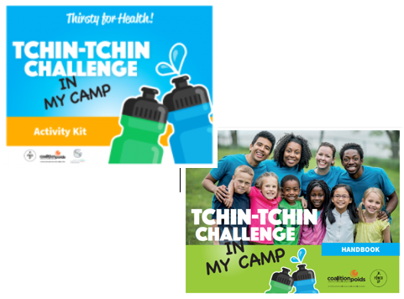
In addition to the Tchin-tchin, the Challenge includes:
- a Tchin-tchin Challenge in my camp Activity Kit;
- a handbook, to successfully take up the Challenge and make the most of it;
- a Special Teen Handbook, including activities (new);
- a 2.0 List of challenges to take up with other counsellors (new);
- a Poster for the Tchin-tchin in my camp Thematic Day (new);
- promotional posters;
- certificates of participation for your campers and the camp;
- suggestions for parents.
All the tools can be downloaded for free at thirstyforhealth.ca/camp and on the Fondation Tremplin Santé website.
By promoting water, you are not only helping to prevent dehydration, but you are also making campers healthier now and in the future. Taking up the Challenge and completing the activities will help campers develop the habit of reaching for water first when they’re thirsty rather than juice or sugary drinks.
The overconsumption of fruit drinks, iced tea, sports drinks, vitamin water, and other sugary beverages is harmful for the teeth and the overall health. It is better to save them for special occasions. In everyday life, water is the drink of choice!
A few simple tips are provided at thirstyforhealth.ca/home/ to help families pursue healthy hydration habits at home.
This summer, to get your campers involved and to give them a taste for drinking water and promoting it as super-ambassadors: discover the Special Teen Handbook!

Thank you for your support. Have a great Tchin-tchin Challenge in my camp week!

The camp coordination team

The Tchin-tchin Challenge in my camp in brief

Before the Challenge
- Consult the Tchin-tchin Challenge in my camp Handbook to help you plan the Challenge.

During the Challenge, from July 5th to 9th
- Each day, organize a morning break, a lunch break, and an afternoon break to focus on water. Make it fun by getting the campers to make a toast. You can even capture these moments in photos! Toasting to healthy hydration doesn't have to mean clinking your glasses and water bottles together. It is possible to raise your glass in a festive and fun way, without touching! Here are some ideas:
  - Challenge yourself and the campers’ creativity and come up with a short song for everyone to sing before taking a sip of water.
  - Create original dance moves.
  - Or, if you don't want to make it complicated, you can simply yell Tchin-tchin with your young campers while raising your water bottle in the air.
- Be sure to have extra water bottles and glasses throughout the week so that campers who forget to bring their own water bottles won't be left out of the toasts during breaks and lunchtime.
- Set a good example by bringing your own water bottle and raise it proudly!
- Complete activities from the Activity Kit.
- Stickers will be distributed to camps which registered for the Challenge before June 11th. Encourage campers to stick them on their water bottles.

After the Challenge ends on July 9th
- To congratulate the campers and reinforce their new habit, sign participation certificates (available at thirstyforhealth/camp).
- Encourage campers to maintain this healthy habit all summer long. Remember to set a good example.

Good luck!

