Dear manager,
Dear coordinator,
The Weight Coalition and the Fondation Tremplin Santé invite your camp to participate in the Tchin-Tchin Challenge in my camp from July 5th to 9th, 2021.
The purpose of this free Challenge is to help camps promote water consumption among campers and therefore improve their health and safety by avoiding dehydration, while having a lot of fun!
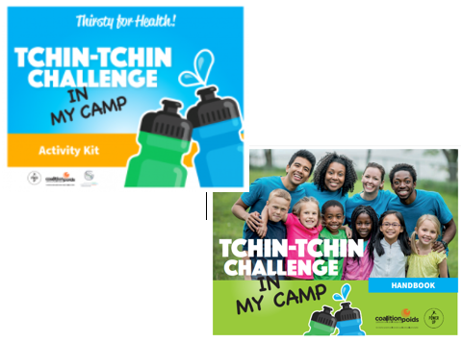
The Tchin-tchin Challenge in my camp includes:
- a Challenge where campers and their counsellors toast together;
- a Tchin-tchin Challenge in my camp Activity Kit;
- a handbook, to successfully take up the Challenge and make the most of it;
- a Special Teen Handbook, including activities (new);
- a 2.0 List of challenges to take up with other consellors (new);
- a Poster for the Tchin-tchin in my camp Thematic Day (new);
- promotional posters;
- certificates of participation for your campers and the camp;
- suggestions for parents.
All the tools can be downloaded for free at thirstyforhealth.ca/camp and on the Fondation Tremplin Santé website.
This summer, camps will have to respect public health rules and physical distancing measures. However, it will still be possible to participate in the Tchin-tchin Challenge in my camp. Indeed, toasting to healthy hydration does not necessarily mean clinking your glasses and water bottles together. It is therefore possible to raise your glasses in a festive and playful way, without contact! In addition, many of the activities proposed in the Challenge kit can be carried out according to public health requirements.
Thank you for your cooperation and support. Please contact us if you have any questions: soifdesante@gmail.com.

Weight Coalition and Fondation Tremplin Santé

